7th Grade Semeter 1 Study Guide 2013

Multiple Choice
Identify the choice that best completes the statement or answers the question.

____ 1. What is a wave?

a. | a disturbance that transfers matter
b. | any type of matter that vibrates back and forth
c. | a disturbance that transfers energy
d. | any type of energy that makes particles move

____ 2. The table below lists the population of Greenwood in 4 different years.

Population of Greenwood
Year | Number of people (thousands)
2005 | 208
2006 | 212
2007 | 217
2008 | 221

What was the population of Greenwood in 2007?
a. | 217,000
b. | 212
c. | 212,000
d. | 217

____ 3. Why do many experiments include several trials instead of a single trial?

a. | Repetition of trials increases the accuracy of the results.
b. | Repetition of trials lets the experimenter change the experimental procedure.
c. | Repetition of trials makes data easier to analyze.
d. | Repetition of trials increases the sample size of the experiment.

____ 4. Through which of these media do sound waves travel MOST slowly?

a. | iron
b. | air
c. | water
d. | wood

____ 5. During a scientific investigation, which step will a scientist likely perform first?

a. | Collect and organize data.
b. | Defend conclusions drawn from data.
c. | Define the problem for investigation.
d. | Plan an experimental procedure.

____ 6. The following picture shows forces acting on a box as it is pushed and pulled across the floor. Sarah wants to stop the motion of the box.

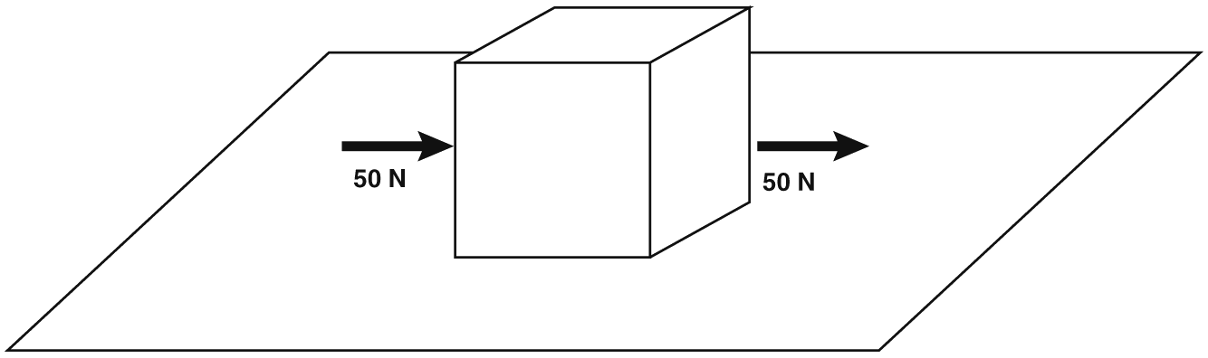

How much force should Sarah use and in which direction should she push to stop the box from moving?

a. | 50 N up
b. | 100 N left
c. | 75 N right
d. | 100 N down

____ 7. A rock is resting on top of a hill. The rock suddenly begins moving down the side of the hill. Why did the rock begin to move?

a. | An unbalanced force acted on the rock and caused it to move.
b. | An upward force balanced the gravitational force, so the rock began to move.
c. | A sudden change in gravitational force caused the rock to begin to move.
d. | Balanced forces caused the rock to move, and then gravity kept it moving.

____ 8. Matthew is trying to push a large box across the gym. Although Matthew is exerting a force, the box does not move. In the following picture, the arrow represents the force Matthew exerted on the box.

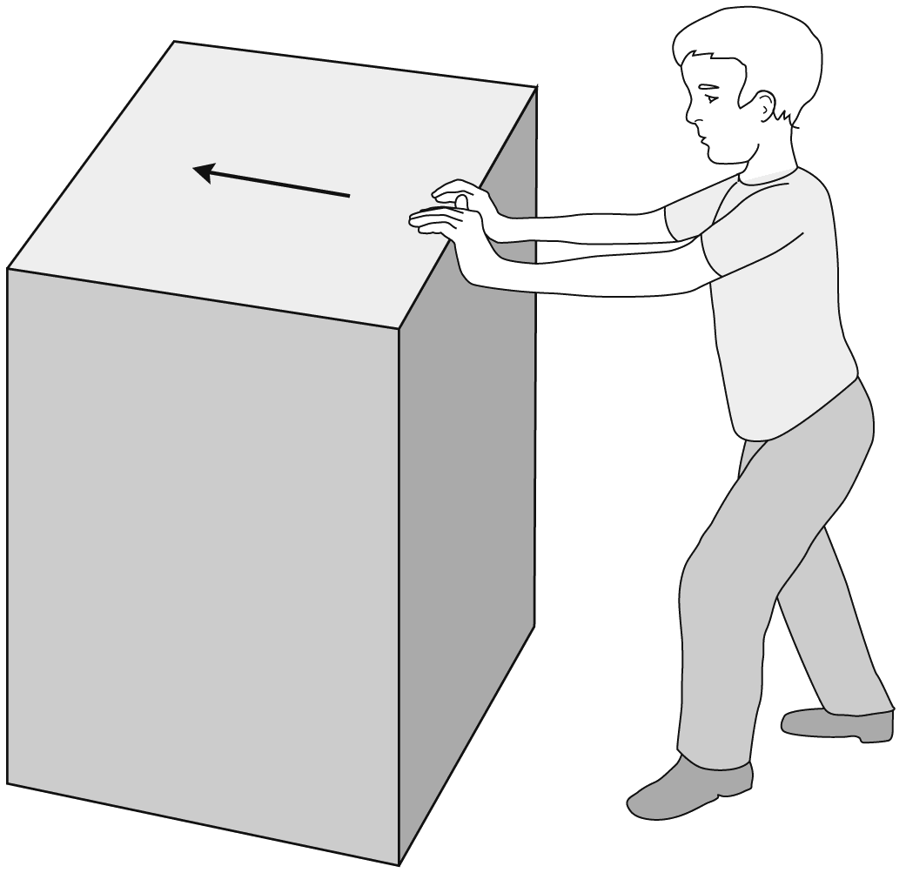

What keeps the box from moving even though Matthew is pushing on it?

a. | A greater vertical force is opposed to the force exerted by Matthew.
b. | The inertia of the box is less than Matthew’s force.
c. | The force exerted by Matthew on the box is not in the right direction to move the box.
d. | An equal and opposite force prevents the box from moving.

____ 9. The table shows different forces and distances that employees in a factory used to lift boxes.

Employee | Force  (N) | Distance  (m)
Ayanna | 24 | 1.5
Rafael | 18 | 2.5
Cassie | 25 | 1.0
Michael | 16 | 2.0

Which employee did the most work while lifting boxes?

a. | Cassie
b. | Rafael
c. | Michael
d. | Ayanna

____ 10. The amount of light energy put out by an incandescent light bulb is under 10% of the electrical energy the bulb uses. What happens to the remaining 90% of the electrical energy used by the bulb?

a. | The electrical energy is destroyed when it is unused by the bulb.
b. | The electrical energy is captured and 90 J are saved for each bulb.
c. | The electrical energy is redirected to other electrical appliances in the circuit.
d. | The electrical energy is transformed into thermal energy, so the bulb becomes hot.

____ 11. A science class investigates how far a machine can throw a ball. The data table below shows the data they collect in four trials.

Trial | Distance traveled by ball (m)
1 | 10.2
2 | 10.3
3 | 10.5
4 | 5.0

Based on the class’s data, how can they improve the accuracy of the investigation?

a. | Use a different ball.
b. | Do more trials.
c. | Erase the data for trial 4.
d. | Change the settings on the ball-throwing machine.

____ 12. The graph below shows the distance a car traveled over 5 seconds while moving on a freeway.

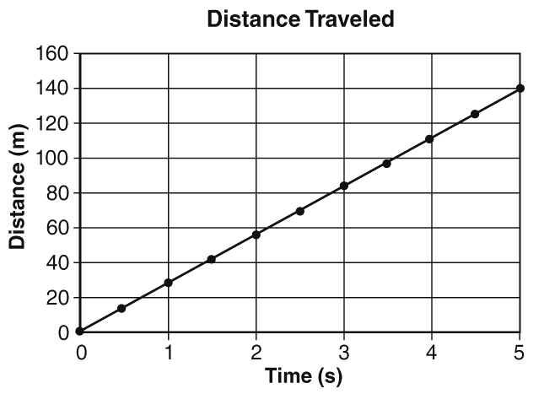

What was the average speed of the car?

a. | 0 m/s
b. | 30 m/s
c. | 28 m/s
d. | 14 m/s

____ 13. In a swimming race, Miho swam the first 50 m in 42 s. She swam the second 50 m in 40 s. What was Miho’s average speed during the race?
a. | 1.22 m/s
b. | 1.25 m/s
c. | 1.19 m/s
d. | 0.82 m/s

____ 14. Which picture shows an object accelerating straight upward?

a. | 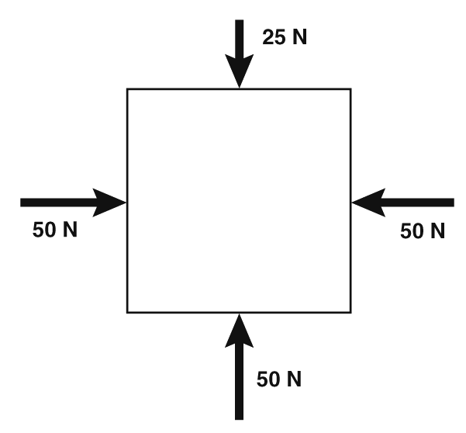
b. | 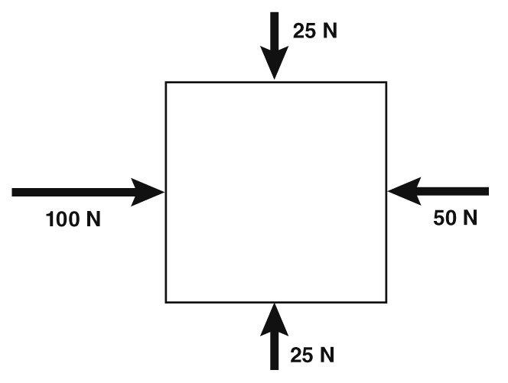
c. | 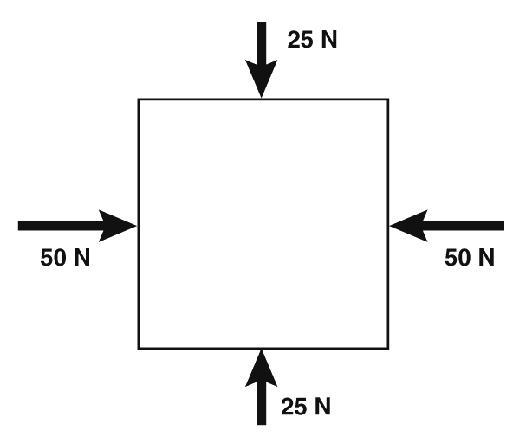
d. | 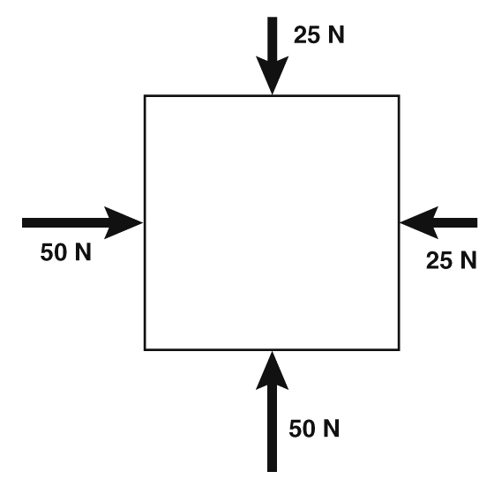

____ 15. Marvin knows that the actual known value for the boiling point of water is 100 °C. He conducts an experiment to measure the boiling point of water in the laboratory. Which of the following results is the MOST accurate?

a. | 102.6 °C
b. | 102.6 °F
c. | 100.4 °F
d. | 100.4 °C

____ 16. Which description defines a dependent variable in a scientific experiment?

a. | a factor that requires tools to measure
b. | any factor that changes during an experiment
c. | a factor that changes due to the independent variable
d. | the set of results for an experiment

____ 17. The graph below shows the speeds of three waves in air and water.

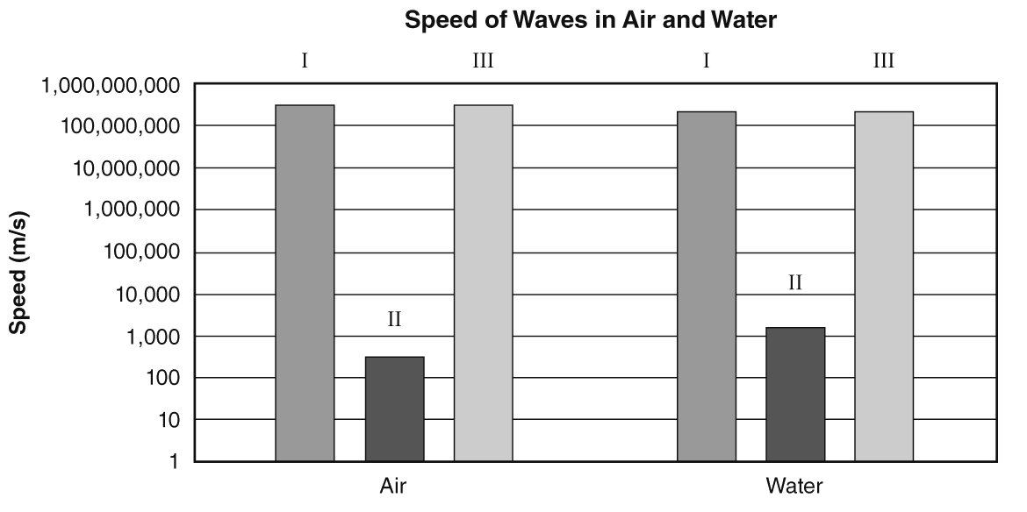
Which wave(s) are electromagnetic waves?

a. | I and II only
b. | I and III only
c. | II only
d. | I, II, and III

____ 18. Feng shines a thin beam of light onto a prism. The light contains wavelengths of red, blue, green, and yellow light. The diagram below shows how the four colors of light exit the prism at different angles.

Which of the wavelengths is color 1?

a. | green light
b. | red light
c. | yellow light
d. | blue light

____ 19. A researcher finds that data from her experiment do not support her hypothesis. What should the researcher do?

a. | Change the data to support the hypothesis.
b. | Change the procedure to obtain the desired result.
c. | Do more trials.
d. | Form a new hypothesis and conduct experiments to investigate it.

____ 20. Which of these is evidence that an unbalanced force is acting on an object?

a. | The mass of the object is changing.
b. | The object remains at rest.
c. | The object continues moving in a straight line at constant velocity.
d. | The motion of the object is changing.

____ 21. If you cook a pizza in a microwave oven, electromagnetic waves warm the pizza, not heat from the surrounding air. Which two types of heat transfer cook a pizza in a microwave oven?

a. | convection and conduction
b. | radiation and convection
c. | convection and insulation
d. | radiation and conduction

____ 22. Jaime planted two seeds. She watered one seed with tap water. She watered the second seed with plant feed. She measured the height of the plant every two weeks. She created the graph below to show her results.
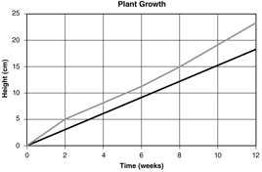

Which of these items is missing from the graph?

a. | units
b. | x-axis
c. | key
d. | title

____ 23. Which piece of equipment can a scientist use to measure the volume of a liquid?

a. | ruler
b. | graduated cylinder
c. | balance
d. | thermometer

____ 24. The following pictures show the positions and directions of a ball at intervals of 1 s. Which picture shows acceleration due to a change in speed?

a. | 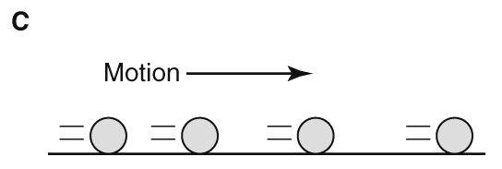
b. | 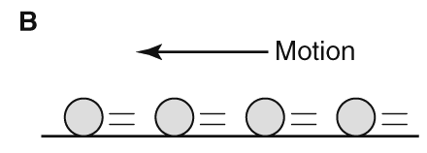
c. | 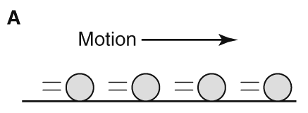
d. | 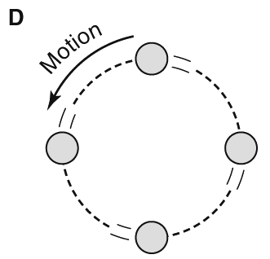

____ 25. This diagram shows a metal spoon is in a bowl of warm mashed potatoes.
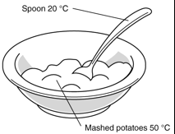

What BEST describes the transfer of energy as heat that is happening in this diagram?

a. | Energy moves by radiation from the potatoes to the spoon.
b. | Energy moves by radiation from the spoon to the potatoes.
c. | Energy moves by conduction from the potatoes to the spoon.
d. | Energy moves by conduction from the spoon to the potatoes.

Short Answer

26. Bar Graph Design

A recent bluegill fish population study was conducted at four different lakes. The results of the study are listed below:

Clark Lake 520 bluegills
Pleasant Lake 380 bluegills
Johnson Lake 610 bluegills
Warrior Lake 660 bluegills

Please use the results from the fish population study to design a bar graph.

27. The diagram below shows forces acting on a box.
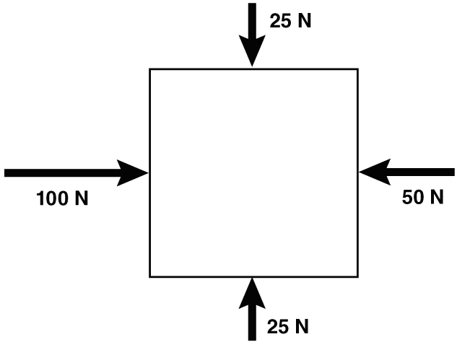

What do the length and the direction of the arrows in the diagram represent?

Are any of the forces acting on the box balanced? How do you know?

Are any of the forces acting on the box unbalanced? How do you know?

Describe the motion of the box as a result of the forces acting on it.

Essay

28. Four alternative energy sources used to generate electrical energy are nuclear energy, biomass, solar energy, and hydroelectric energy. Like all energy sources, each of these has both advantages and disadvantages. For each of these four energy sources, describe one way that it is either beneficial or harmful to the environment.

Nuclear energy

Biomass

Solar energy

Hydroelectric energy

