Study Guide:
Name:_____________________Date:___________Period:______________

A NUCLEUS | B CHROMATIN
C NUCLEOLUS | D. NUCLEAR PORE
E. ROUGH E. R. | F SMOOTH E.R.
G. VACOULE | H. CYTOPLASM
- CHLOROPLAST | J. CELL WALL
K. CELL MEMBRANE | L. MITOCHONDRIA
M. VESICLE | N. GOLGI COMPLEX

- Identify each part of the cell pictured and labeled below.
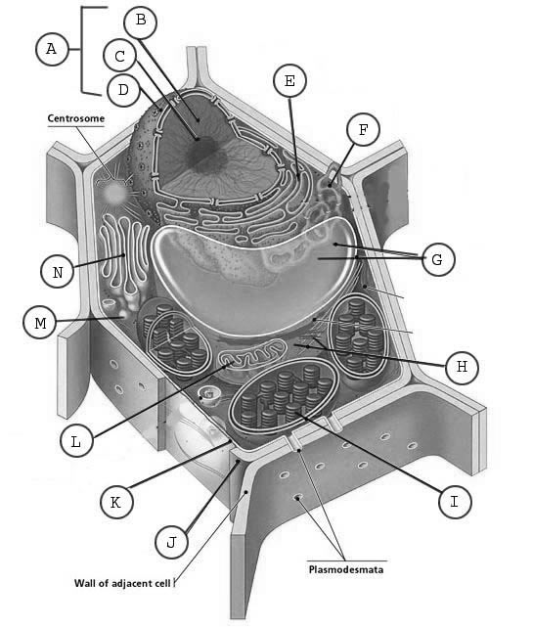

- Fill out the chart below
Organelle | Function | Cells it’s found in
Nucleus | Holds and protects DNA | All eukaryotes
Ribosomes | Builds proteins | All cells
Nucleolus | Builds ribosomes | All eukaryotes
Rough E.R. | Helps build proteins and transport them throughout the cell | All eukaryotes
Smooth E.R. | Builds lipids and detoxifys | All eukaryotes
Golgi complex | Sorts and packages proteins | All eukaryotes
mitochondria | Creates energy, cell respiration | All eukaryotes
chloroplast | Creates sugar | Plant cells: eukaryotes
Cytoplasm | Chemical reactions, holds organelles in place | All cells
Cell membrane (plasma membrane) | Controls homeostasis | All cells
Vacuole | Stores water, food, and waste | All eukaryotes
Lysosome | Breaks down waste material | All eukaryotes
Cell Wall | Extra support and structure | Prokaryotes and plant cells
Centriole | Helps with mitosis | Eukaryotic animal cells
- Differentiate between eukaryotic and prokaryotic cells.
Eukaryotes have a nucleus, membrane bound organelles, are larger, more complex, can be multicellular and prokaryotic cells are not. Prokaryotic cells evolved first.

- Fill out the chart below

Types of Transport | Direction of molecules | Uses proteins | Uses energy
Simple diffusion | High to low | No | No
Facilitated diffusion | High to low | Yes | No
Osmosis | High to low | Yes | No
Active Transport | High to low | Yes | yes

- How does the cell membrane control homeostasis?
It controls what enters and leaves a cell since it is semi-permeable.

- For each picture indicate which part is hypotonic, hypertonic, and isotonic. Draw an arrow showing the direction of water movement and describe what will happen to the cell in each.

Cell: hypertonic Cell: hypotonic cell: isotonic
Solution: hypotonic solution: hypertonic solution: isotonic
Water: moves into the cell water: move out of cell Water: both ways
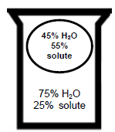
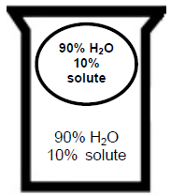
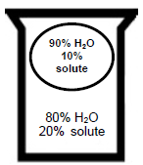

- Which solution, hypertonic, hypotonic, or isotonic, has the most solutes? Which solution has the most water?
Hypertonic has the most solute
Hypotonic has the most water

- How do enzymes speed up a chemical reaction
Lowers the activation energy to start a chemical reaction

- What could change the shape of an enzyme?
pH, temperature, salinity, inhibitors

- Why are enzymes specific to one type of substrate?
Because substrates have to fit into the active site, which has a specific shape for one type of molecule.
11. According to the figure below:
  - Which enzyme (X or Y) would you expect to find in a bacterium growing in a hot spring? Explain your rationale.

Y, because it has a higher optimum temperature

  - According to the figure below, what are the optimum temperatures for each enzyme(X and Y)? How do you know?
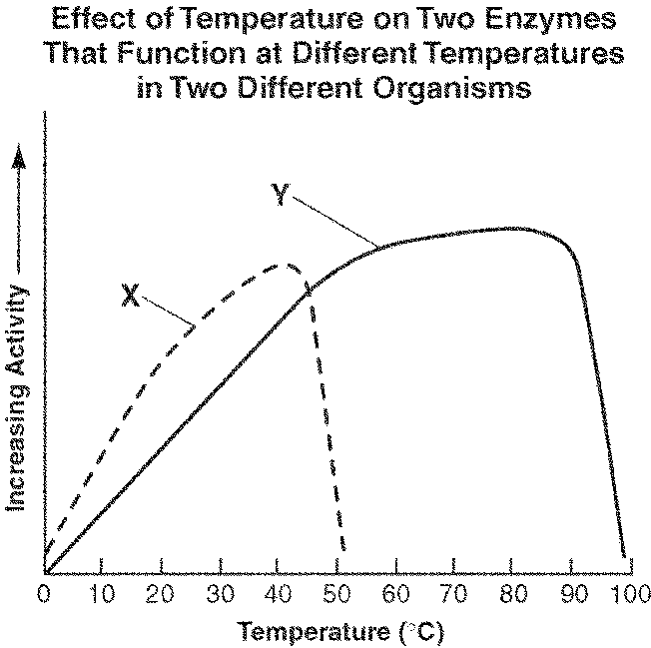
x=42 degrees C
Y=88 degrees C
It’s the highest peak of
Enzyme activity

