Cell Structure and Function Study Guide
- Know the differences between eukaryotic and prokaryotic cells. Be able to make a chart with both and discuss their differences.

- Be able to identify an animal cell, plant cell and a bacterial cell.

- Know the three parts of the cell theory.

- Know what cilia and Flagella are and what they are used for by the cell.

- Know what chromatin is and where it is found in the cell.

- Know the function of these organelles and be able to find them on a diagram like the one below (Ignore Letters B and M) This will be the majority of point on this QUEST!!!!!!!!:

  - Cell Wall
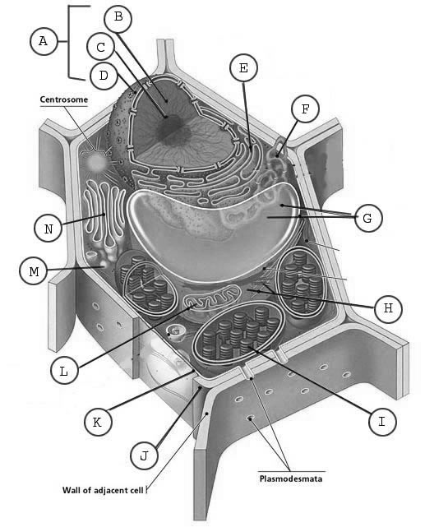
  - Cell (Plasma) Membrane

  - Nucleus (Know what it makes)

  - Nucleolus (Know what it makes)

  - Mitochondria (Know what it makes)

  - Chloroplast

  - Cytoplasm

  - Vacuoles

  - Lysosome

  - Nuclear Pores and Nuclear Membrane

  - Smooth and Rough Endoplasmic Reticulum
(Know what both make)

  - Golgi Apparatus

  - Ribosomes (Know what it makes and where they are found)

  - Centrioles (Already Identified on the chart for you (What do they do?)

Cell Membrane & Cell Transport Test Review

____ 1. Selective permeability
____ 2. Diffusion
____ 3. Osmosis
____ 4. Concentration Gradient
____ 5. Passive Transport
____ 6. Isotonic
____ 7. Hypotonic
____ 8. Hypertonic
____ 9. Facilitated Diffusion
____ 10. Active Transport
____ 11. Endocytosis
____ 12. Exocytosis

A. The difference in concentration of a substance from one location to another.
B. A solution that has a lower solute concentration compared to another solution.
C. The movement of molecules in a fluid of gas from high concentration to a lower concentration.
D. A solution that has a higher solute concentration compared to another solution.
E. The release of substances outside of a cell by the fusion of a vesicle with the membrane.
F. Allows some, but not all, materials to cross a membrane.
G. Taking materials into a cell by engulfing them in a membrane.
H. Movement of molecules across a membrane from a lower to higher concentration; requires energy.
I. The movement of molecules across a cell membrane without energy input from the cell.
J. The diffusion of molecules across a membrane through transport proteins.
K. A solution that has the same solute concentration as another solution.
L. Movement of water across a semipermeable membrane from higher to lower water concentration.

Things to know:
1. What is the function (job) of the cell membrane? Hint= Balance by protection.

2. What is the difference between passive and active transport? Give examples of each type of transport. Which proteins are use by each kind

3. What are the parts of the phospholipid? Which is hydrophobic and hydro phillic? Which contains glycerol? Fatty Acids?

4. How many phospholipid molecules thick is the cell membrane?

5. What is the difference between diffusion and osmosis?

6. What is the difference between solute concentrations inside and outside of the cell called?

7. Does passive or active transport move molecules against their concentration gradient?

8. What is the difference between diffusion and facilitated diffusion.

9. Look over hypertonic and hypotonic and be able to draw arrows showing water movement and identify hypertonic, hypotonic, and isotonic solutions.
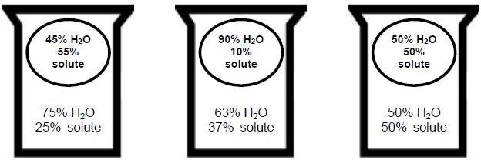

10. Be able to explain why the egg lost or gained mass in the osmosis experiment using the terms: Osmosis, diffusion, hypertonic, hypotonic, water, solution.

11. Which type of transport requires energy? What is that energy called? Why does it require energy?

12. The plasma membrane is semipermeable. What does that mean?

13. When is endocytosis or exocytosis necessary for a cell to use? Does the molecule actually pass through the cell membrane?

