Name:______________________________________Date:____________________Period:___________

Type of transport | What direction do molecules travel? | Does it use energy? | Does it use a channel protein? | Draw a picture that shows this type of transport
Passive Transport
(diffusion and osmosis)

Active Transport

Endocytosis

Exocytosis

2. Draw molecules traveling through the cell membrane below through the process of diffusion.
a. Label each side as either low or high concentrations
b. draw an arrow showing the direction of molecules
c. make sure the molecules are a specific color

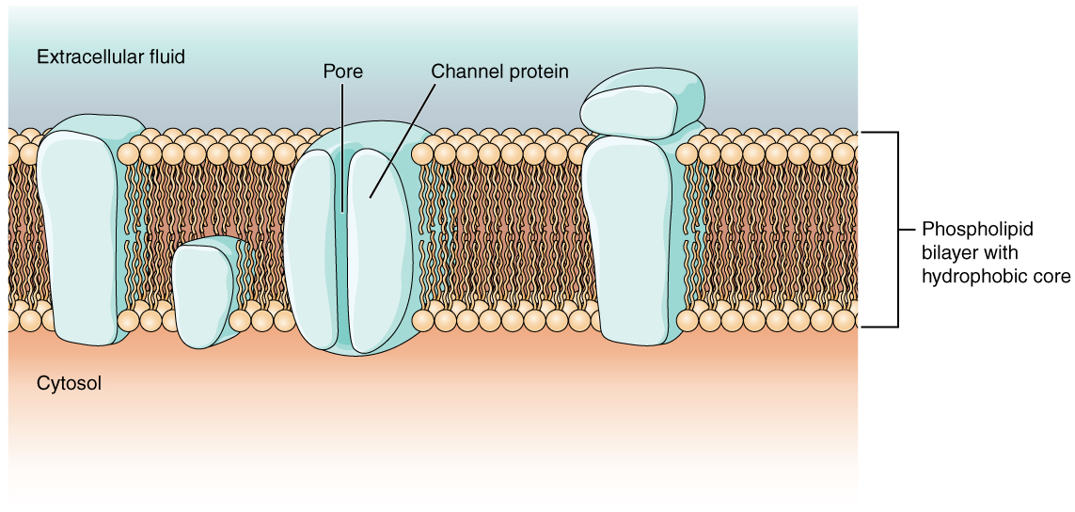
3. Draw molecules traveling through the cell membrane below through the process of active transport
a. Label each side as either low or high concentrations
b. draw an arrow showing the direction of molecules
c. make sure the molecules are a specific color (different from the color used on number two)

