DNA Structure, Replication, Transcription and Translation (HONORS)
DNA STRUCTURE
- What is the function of DNA? What does it code for? What is the monomer of DNA?
- What are the parts that make up the structure of DNA (3 parts of a nucleotide)?
- Which bases bind to each other in DNA?
- What is the alternating sugar phosphate structure called?
- What is the twisted structure of DNA referred to as?
- What DNA stands for and why deoxyribose is in the name?
- What kind of bonds hold the nitrogen bases together? This is called _____________ base pairing?
 | Adenine | Thymine | Cytosine | Guanine
Humans | 30
- A + T + C + G = ____________%
- Be able to complete a chart like the one above.
- How do you determine the 5’ and 3’ end of DNA?
- Who used Xrays to find the structure of DNA and was cheated out of a Nobel Prize?
- Who were given credit for finding out DNA was a Double Helix?
REPLICATION
- What is the purpose of DNA replication?
- Replication results in one _________ strand and one _________ strand?
Transcription and Translation
- Transcription and translation = DNA ______ __________
- What are the differences between RNA and DNA?
- Know what the end product of transcription is. Know what the end product of translation is.
- What does the “M” in mRNA stand for? What is the job of mRNA?
- Know what tRNA and rRNA stand for and what their jobs are!
- What nitrogen base replaces Thymine in RNA? What Bases bind in RNA?
- What is the enzyme that unzips the DNA and adds nucleotides to the growing mRNA strand in transcription?
- What are the factors called required for the above enzyme to attach to the DNA? _______________ factors!
- Where in the cell does transcription take place? Where in the cell does translation take place?
- Which type of RNA is the codon found on? Which type of RNA is the anticodon found on?
- How many bases make up a codon or anticodon?
- A chain of amino acids makes what?
- What is the only start codon found on mRNA?
- What is a stop codon?
- Be able to transcribe and translate something like this:
DNA: ATG ACT AGC TGG GGG TAA TAC TTT TAG
mRNA:
tRNA:
Amino Acid:
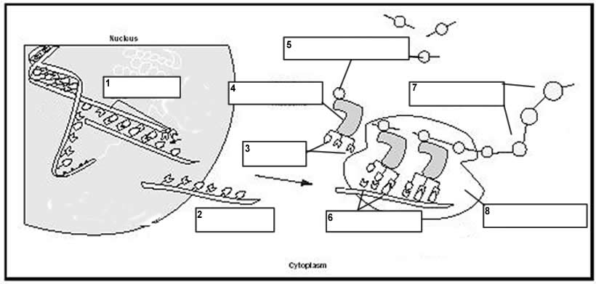
- Be able to label a picture of transcription and translation:

Gene Regulation:
- How are genes controlled?
- Explain two ways a gene can be turned on and two ways they can be turned off.
- Why is gene regulation important in multicellular organisms?

