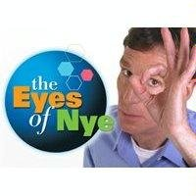
The Eyes of Nye
Pseudoscience

- What is pseudoscience?

- Experimental results in science must be repeatable. What does this mean?

- Bill Nye makes an “extraordinary claim” that an inflated red balloon will move forward in an accelerating car. Does it work? What is the explanation?

  - Why is this a good example of a hypothesis?

- Each of these is a field of study often presented as scientific, without any actual scientific evidence. What percent of people believe in each?

  - Magnetic Therapy:

  - Extra-Sensory Perception (ESP):

  - Astrology:

  - Communication with the dead:

- How do psychic readings, tarot card readings, and palm readings really work?

- How have the constellations changed in the last 2000 years, and how does it affect astrology?

- Why are rhinoceros poached for their horns? What material are the horns really made of?

- With dietary supplements, does natural mean safe? Give an example.

- What is the most popular use for herbal supplements?

- Certain dietary supplements have side effects, meaning their use should always be reported to your doctor. Give an example of one of these side effects.

- Anthony Choice, life coach, has a much different explanation for fire walking than Bill Nye does. Describe both sides.

  - Why wouldn’t Anthony’s explanation fit within the definition of science?

