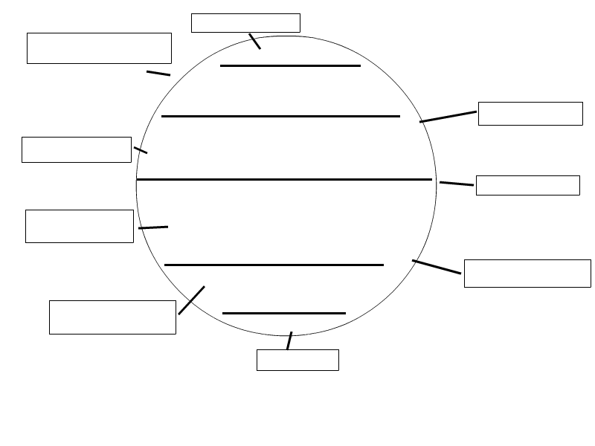
Terms:
Horse latitudes , Trade Winds, Westerlies, Doldrums, Polar Easterlies. (you will use some of these more than once)
Make sure to include the latitudes that each dark line represents.

