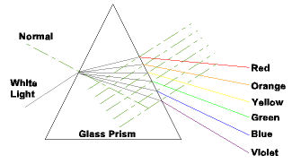

- Label each color of visible light as it leaves the prism

- What is different about each color of visible light?

- Why do the colors refract from the prism in that order every time?

