Name:_________________________Date:___________________Period:________________

1. For each picture determine what direction natural section is going and explain why it is going in that direction.
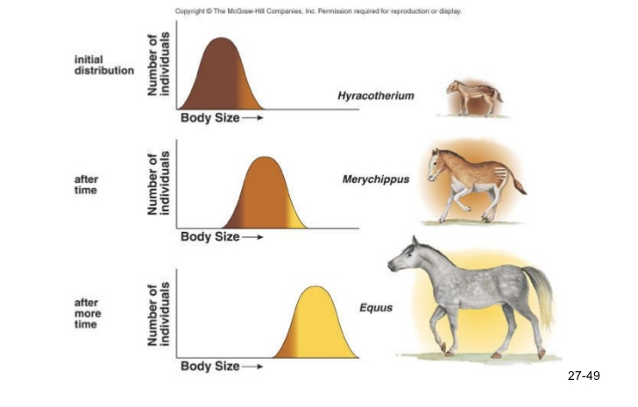
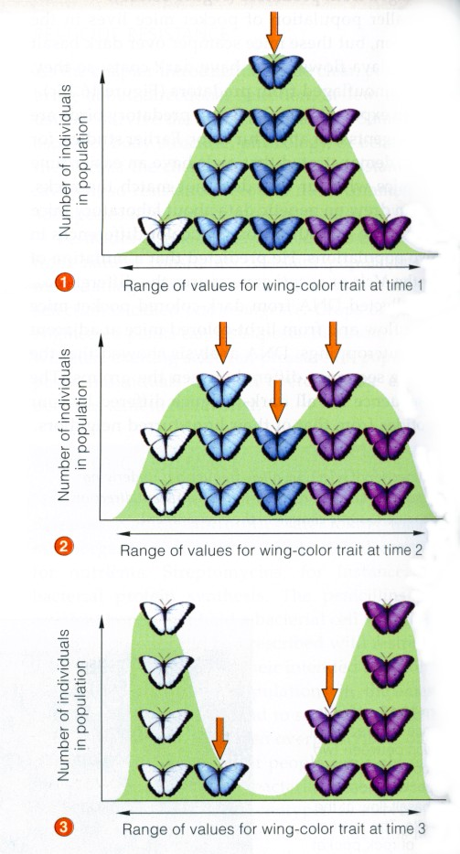

2. What are the different types of selection forces that cause evolution to occur in a population?
Selection force | example

3. What causes evolution in a population that has nothing to do with selection? Give examples of each.

