The Impact of Invasive Species
- By Alexandre Meinesz
- Posted 04.01.03
- NOVA
Caulerpa taxifolia, the "killer alga," is just one dramatic example of an accelerating phenomenon—the homogenization of the biosphere by species introduced to every continent and island. Inadvertently or deliberately, humans have always carried species from one region to another and, ultimately, between continents, but the development of rapid means of transportation has greatly increased the frequency of such introductions.
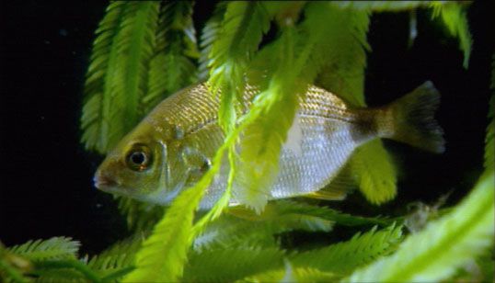
While ideal for saltwater aquariums, "killer alga" is actively overwhelming native species in the Mediterranean Sea. EnlargePhoto credit: WGBH/NOVA/BBC Horizon
Many introduced species have invaded natural habitats to the detriment of one or more native species. Aside from economic consequences of varying degree, including loss of recreation and tourism, such invasions threaten biodiversity in those habitats. To gain a better understanding of such threats, one can erect a hierarchy of impacts on biodiversity. At each hierarchical level, the gravity of the case depends on the vigor of the invader, its dominance, its rate of spread, and its persistence.

DEGREES OF MENACE
At the first level, the introduced species maintains itself in a limited range of habitats without spreading and without upsetting the equilibrium of the ecosystem. The species thus occupies an "empty" ecological niche. This situation allows two interpretations. First, one can see the introduction as an alteration of the ecosystem by an alien element that at least modifies the species composition, even if it appears innocuous otherwise. Second, one can, by contrast, see this introduction as beneficial because it has enhanced local biodiversity.
At the second level, the introduced species spreads to the detriment of one or a few native species. It thus threatens native biodiversity. The eastern North American gray squirrel (Sciurus carolinensis), for example, was introduced to Great Britain beginning in 1876. It has spread widely and outcompeted the native red squirrel (Sciurus vulgaris), particularly in deciduous woodlands and manmade habitats. Populations of the native species have continued to decline, but this is the only major impact of the gray squirrel documented in Great Britain.
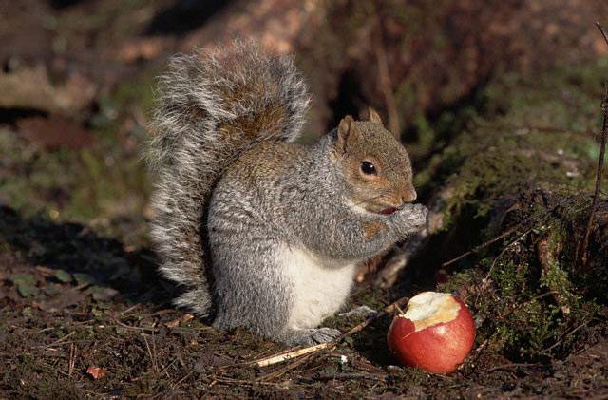
It looks benign enough, but the North American gray squirrel has outcompeted the native red squirrel in England, causing its decline there. EnlargePhoto credit: © Corbis Images
At the third level, the introduced species becomes dominant and alters or upsets the entire ecosystem. One of the most dramatic and damaging invasions of the past quarter century involves a single species of comb jellyfish, a jellyfish-like marine animal also known as a ctenophore ("ten-oh-for"). Looking like a small, translucent medusa, this willowy creature demonstrates the enormous impact that a small, apparently innocuous species can have in a new habitat.
Native to estuaries along the western Atlantic coast from the northern United States to the Valdés peninsula in Argentina, Mnemiopsis leidyi (as this species of comb jellyfish is known scientifically) appeared in the Black Sea in 1982. It was almost certainly introduced by a ship that loaded Mnemiopsis-laden ballast water in the western Atlantic and then emptied its tanks in the Black Sea. At first, the ctenophore was misidentified, and not until 1989 did authorities recognize it as a species of Mnemiopsis and thus an invader.
The species usually has moderate population densities in the western Atlantic, but its populations exploded in the Black Sea and the adjacent Azov Sea and Sea of Marmara. M. leidyi has invaded the entire Black Sea, a practically closed body of water that communicates with the Sea of Marmara and thus the Mediterranean through the Turkish strait of Bosporus.

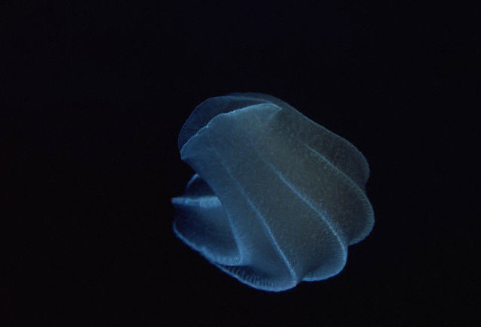
The comb jellyfish has recently arrived in the Caspian Sea via the Black Sea, where it triggered the catastrophic collapse of local fisheries.EnlargePhoto credit: © Corbis Images
The Black Sea has two unusual features. On the one hand, it is naturally sterile at great depths; there is no oxygen between 660 feet and the deepest regions, which surpass 6,600 feet. On the other hand, it is highly polluted, as it receives the great rivers of eastern Europe and Russia, which drain the effluent of many giant factories and large cities with inadequate sewage treatment. Indeed, the quantities of nutrients, insecticides, fungicides, herbicides, heavy metals, organic compounds, hydrocarbon derivatives, and radioactive waste found on the edges of the Black Sea near the deltas of the great rivers are all worthy of mention in the Guinness Book of World Records.
Despite this unenviable situation, which would not seem conducive to life, the catch of pelagic fishes (primarily anchovy, sprat, and horse mackerel) had always been good. But when Mnemiopsis exploded in 1988—up to 500 individuals per cubic yard—and devoured all the zooplankton, including fish larvae, the entire pelagic ecosystem was profoundly modified, and the catch plummeted. The anchovy catch fell from 204,000 tons in 1984 to 200 tons in 1993; sprat from 24,600 tons in 1984 to 12,000 tons in 1993; horse mackerel from 4,000 tons in 1984 to zero in 1993. A simple little comb jellyfish caused more damage to the fishery than the various pollutants so often decried!
The Mnemiopsis population began to collapse in 1991 as its food base declined, but the comb jellyfish is still present, with drastic annual population fluctuations. Though we can reasonably hope for a reduction in pollution from the Danube, Dnieper, Don, and Dniester Rivers, what can we hope to do against Mnemiopsis, which has overthrown the entire pelagic ecosystem of the Black Sea (and has lately arrived in the Caspian Sea via rivers and canals connecting it to the Black)?

THREAT OF THREATS
At the fourth level, the introduced species affects several ecosystems, thus threatening an even larger swath of biodiversity. Regrettably, the number of invaders of this sort is growing. For the most part, they are species able to tolerate a wide variety of habitats, or those in such great densities that they disturb all the ecosystems surrounding the one they inhabit.
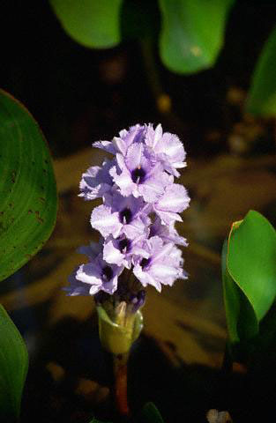
The water hyacinth's beauty (top) belies its ability to choke off both standing and running bodies of water (above).EnlargePhoto credit: © Corbis Images
Water hyacinth (Eichhornia crassipes) is one of the most widespread invaders worldwide. A century after its first introduction outside its native range, the Amazon basin, it infests numerous tropical lakes, estuaries, streams, and rivers. A beautiful plant that attracted botanists seeking ornamentals for botanical gardens, it was imported to a horticultural exposition in New Orleans in 1884. Visitors were impressed by its beauty and planted it in several water bodies.
The aquatic ecosystems of the southeastern United States were then progressively colonized by vast, floating, dense carpets of water hyacinth. The economic repercussions, particularly interference with navigation, first drew attention, but the presence of an opaque covering of plants on the water surface and the eventual decomposition of dying plants devastated numerous aquatic ecosystems, both planktonic and on the bottom. At one time, water hyacinth dominated 123,500 acres of Florida waters. There it has been reduced to a minor problem, primarily by the use of chemicals and large floating mechanical reapers, but the plant remains a pest in many states, particularly Louisiana.
Water hyacinth reached Africa in 1892, then Asia in 1894 (after being brought to a botanical garden in Indonesia). Today water hyacinth is present around the globe on thousands of miles of streams and rivers. It first appeared in great quantity in Lake Victoria in 1989; today it covers well over 12,000 acres and is spreading. It wreaks havoc with the commercial fishery, fouls boat engines and propellers, obstructs landing sites, and clogs cooling pipes for power plants, leading to massive blackouts. The impact on native species must be enormous but is largely unstudied. This insufficient scientific documentation of ecological impact is lamentably common for most ecosystems invaded by this plant.
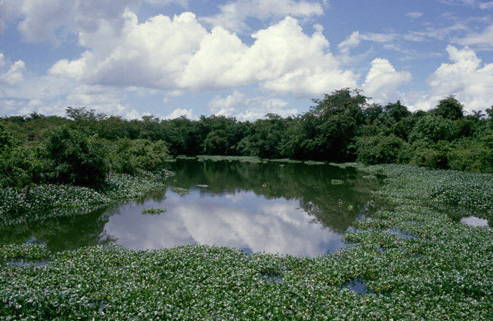
The water hyacinth's beauty (top) belies its ability to choke off both standing and running bodies of water (above).EnlargePhoto credit: © Corbis Images
Caulerpa taxifolia, the killer alga, is a dominant, ubiquitous, persistent, and rapidly spreading introduced species. Having colonized a wide variety of habitats, it falls squarely in level four, the highest degree of threat to plants and animals. The fact that it appears to be a single individual, a clone, of a genotype unknown in nature makes it an exceptional and particularly unsettling case.

INVADING THE WORLD
In the U.S., more than 7,000 introduced species (not counting microorganisms) are established in nature, of which perhaps 15 percent cause ecological or economic damage. Some recent cases are rapidly evolving. The cordgrass Spartina alterniflora of the Atlantic coast of the United States has invaded the soft-bottom coasts of California and Washington, completely transforming intertidal ecosystems. Kudzu (Pueraria montana), a Chinese vine, has spread through the forests of the Southeast and Hawaii, covering more than four million acres with a green curtain. The European green crab (Carcinus maenas) is invading the Pacific coast (and also Tasmania) in enormous numbers, with major impacts on coastal benthic food webs.
Each invading species is a unique case, with characteristic impacts, degrees of dominance, and features of dispersal. Thus each invasion has been treated differently. But the succession of invasions, each dramatic in its own way, that spreads rabbits, rats, camels, horses, deer, birds, frogs, toads, snakes, fishes, insects, jellyfish, crustaceans, mollusks, starfish, sea urchins, dinoflagellates, macroalgae, ferns, and higher plants is dizzying.
Even as the atlas of plant and animal pests continuously expands, legislation to stem this tide, while drastic in a few nations, is rare or nonexistent in the majority. The scientific illiteracy with respect to the global threat posed by invasive introduced species means that other ecological horrors are much more in the news. Insidious (because it seems natural), progressive, underestimated—this is nature of the blow that human-introduced species strike against biodiversity. Has it not already surpassed that caused by the sum of all chemical pollution?
Biodiversity is the variety of life. It can be studied on many levels. At the highest level, you can look at all the different species on the entire Earth. On a much smaller scale, you can study biodiversity within a pond ecosystem or a neighborhood park. Identifying and understanding the relationships between all the life on Earth are some of the greatest challenges in science.

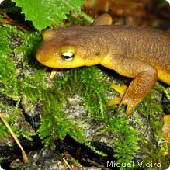
Most people recognize biodiversity by species. A species is a group of living organisms that can interbreed. Examples of species include, blue whales, white-tailed deer, white pine trees, sunflowers and microscopic bacteria that you cannot even see with your eye. Biodiversity includes the full range of species that live in an area.
Biodiversity at a Glance

Let’s look at the species biodiversity within a local pond. At first glance, we can identify different plants, including cattails and water lilies. If we wait a while, we might be able to spot a garter snake, a bullfrog or maybe a red-winged blackbird. With a closer look, you can see invertebrates and worms under leaves, on grasses and in the pond water.
Think you’re done? - You have not even scratched the surface of the biodiversity within the pond! Using a microscope, you would be able to see hundreds or even thousands of different bacteria that inhabit the pond water. They are all part of the species biodiversity of this small ecosystem!

Biodiversity is More than Just Species
Species diversity is only one part of biodiversity. To properly catalogue all the life on Earth, we also have to recognize the genetic diversity that exists within species as well as the diversity of entire habitats and ecosystems.
Genetic Biodiversity is the variation in genes that exists within a species. A helpful way to understand genetic diversity is to think about dogs. All dogs are part of the same species, but their genes can dictate whether they are Chihuahua or a Great Dane. There can be a lot of variation in genes – just think about all the colors, sizes, and shapes that make up the genetic diversity of dogs.
Ecological Biodiversity is the diversity of ecosystems, natural communities and habitats. In essence, it’s the variety of ways that species interact with each other and their environment. The forests of Maine differ from the forests of Colorado by the types of species found in both ecosystems, as well as the temperature and rainfall. These two seemingly similar ecosystems have a lot of differences that make them both special.
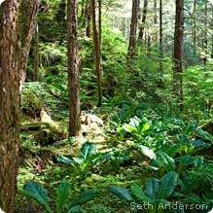

Some Biodiversity Facts
Researchers have estimated that there are between 3 - 30 million species on Earth, with a few studies predicting that there may be over 100 million species on Earth! Currently, we have identified only 1.7 million species, so we have a long way to go before we can come close to figuring out how many species are on Earth!
- There is more biodiversity within tropical ecosystems than temperate or boreal ecosystems. Tropical rainforests have the most diversity.
- The most diverse group of animals are invertebrates. Invertebrates are animals without backbones, including insects, crustaceans, sponges, scorpions and many other kinds of organisms. Over half of all the animals already identified are invertebrates. Beetles are some of the most numerous species.
- Science has so much more to learn about the biodiversity of microscopic organisms like bacteria and protozoa.

The Importance of Biodiversity
Biodiversity is extremely important to people and the health of ecosystems. A few of the reasons are:
- Biodiversity allows us to live healthy and happy lives. It provides us with an array of foods and materials and it contributes to the economy. Without a diversity of pollinators, plants, and soils, our supermarkets would have a lot less produce.
- Most medical discoveries to cure diseases and lengthen life spans were made because of research into plant and animal biology and genetics. Every time a species goes extinct or genetic diversity is lost, we will never know whether research would have given us a new vaccine or drug.
- Biodiversity is an important part of ecological services that make life livable on Earth. They include everything from cleaning water and absorbing chemicals, which wetlands do, to providing oxygen for us to breathe—one of the many things that plants do for people.
- Biodiversity allows for ecosystems to adjust to disturbances like extreme fires and floods. If a reptile species goes extinct, a forest with 20 other reptiles is likely to adapt better than another forest with only one reptile.
- Genetic diversity prevents diseases and helps species adjust to changes in their environment.
- Simply for the wonder of it all. There are few things as beautiful and inspiring as the diversity of life that exists on Earth.

Threats to Biodiversity
Extinction is a natural part of life on Earth. Over the history of the planet most of the species that ever existed, evolved and then gradually went extinct. Species go extinct because of natural shifts in the environment that take place over long periods of time, such as ice ages.
Today, species are going extinct at an accelerated and dangerous rate, because of non-natural environmental changes caused by human activities. Some of the activities have direct effects on species and ecosystems, such as:
- Habitat loss/ degradation
- Over exploitation (such as overfishing)
- Spread of Non-native Species/ Diseases
Some human activities have indirect but wide-reaching effects on biodiversity, including:
- Climate change
- Pollution
All of these threats have put a serious strain on the diversity of species on Earth. According to the International Union for Conservation of Nature (IUCN), globally about one third of all known species are threatened with extinction. That includes 29% of all amphibians, 21% of all mammals and 12% of all birds. If we do not stop the threats to biodiversity, we could be facing another mass extinction with dire consequences to the environment and human health and livelihood.
Questions:
1. What is biodiversity and what areas of the earth have the most biodiversity and the least biodiversity? Why?
2. What are the threats to biodiversity? Why should humans worry about biodiversity?

3. How have invasive species affected biodiversity?
4. Why are invasive species a problem? How can we protect ecosystems from or treat those which have been affected by invasive species?
5. Highlight all the evidence from the article to support your conclusions and label them by the question they support.

