Unit 2 Study Guide
Name_____________________________________ Class Period______________
Unit 2 Test is Friday, September 26th. The test will have multiple choice questions, one diagram and short answer questions. The study guide is due Wednesday, September 24th. Besides answering all the questions on this study guide, you need to study all of the worksheets, labs, and quizzes that are in the Unit 2 section of your Science binder.
Lesson 1 – Pages 74-82
- Write down 9 different physical properties of matter.

- Write down 2 chemical properties of matter.
- Can you observe the physical properties of matter without changing the identity of the substance?

Lesson 2 – Pages 92-99
- Write down two examples of physical changes.

- Write down two examples of chemical changes.

- If Mr Nobbe uses a magnet, boiling water, and a filter to separate a mixture, what type of change did she use to separate the mixture? Circle the correct answer.
Physical or Chemical

- What are the 5 signs of a chemical change?

- If Mrs. Sever dissolved some salt in a beaker of water, the process involved a physical change. Mrs. Sever wants to recover just the salt in the solution. How could she do this?

Lesson 3 – Pages 104-113
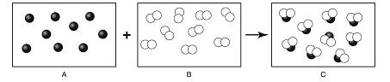
- Look at the above diagram. What type of substance is reactant B?
- Look at the above diagram. What type of substance is product C?
- What type of substance is always made up of a single type of atom?

- What type of substance contains an arrangement of different types of atoms joined together by chemical bonds?

- How are mixtures formed? How are mixtures separated? Circle the correct answer.
Physical Changes or Chemical Changes

- How are pure substances formed? How are pure substances broken down? Circle the correct answer.
Physical Changes or Chemical Changes

- What are the two types of pure substances? Use page 113 in your binder or book.

- What are the three types of mixtures? Use page 113 in your binder or book.

- What is the smallest particle of an element that has all the chemical properties of the element?
Lesson 4 – Pages 120-125
- How are the elements in the periodic table arranged?

- What two particles make up the nucleus of an atom?

- What is the mass number of an atom that has 3 protons, 3 electrons and 4 neutrons?

- Carbon has 6 protons. What would happen if the element Carbon gained a proton?

- An atom’s mass number is 200 and its atomic number is 75. How many neutrons does the atom have?

- Helium has an atomic number of 2. What does the atomic number tell you about the element Helium?

- Circle the following items that are not made out of atoms.
Trees Water Protons Electrons Humans Air

- How do the particles of a gas compare to the particles in a liquid?

- Label the below diagram.
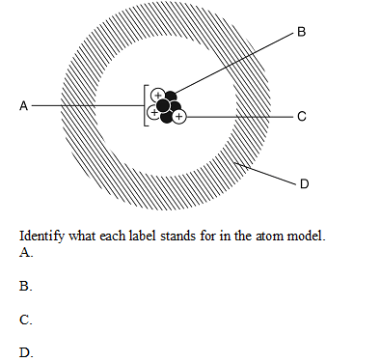

Lesson 5 – Pages 130-137
- What is the name for a horizontal row in the periodic table?

- What is the name for a vertical column in the periodic table?

- An atom of Gallium (Ga) has 31 protons and 39 neutrons. What is the atomic number of Gallium?

- What do the elements in the table have in common?
- What are the 3 categories that elements on the Periodic Table can be divided into?

- Copper, Gold and Iron are examples of what?

- Look at the diagram below of the element Calcium.
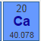

- Most of the elements on the Periodic Table are ______? Circle the correct answer.
Metals Nonmetals Metalloids

